**Waiting for a neurodevelopmental assessment**

**Information and support for parents and carers**

**Contents**

About this guide 2

Section 1: Referral and assessment 4

Section 2: Advice from parents and carers 8

Section 3: Support you can access now 10

About this guide



Who is this guide for?

This guide is forparents and carers of children and young people in Gateshead who are waiting for a diagnosis for neurodevelopmental needs.

**Please note:** we have used "child" throughout this guide to mean "child or young person". This means the person under 18 years old that you are responsible for.



Why have I been given this information?

You or someone else, like a doctor, therapist or teacher, may have noticed certain things about the way your child behaves.

Every child is different. But you may be worried that your child:

* doesn't like or doesn't cope well with changes to routine
* finds it hard to control their emotions
* has delays with learning to talk or understanding words
* has a small number of very intense interests
* finds social situations hard to deal with
* has trouble concentrating
* is restless or hyperactive
* seeks out or avoids certain sounds, smells, tastes, textures (sensory experiences)

These concerns may have made you or someone else think about whether your child has neurodevelopmental needs.



What are neurodevelopmental needs?

Neurodevelopment means the development of the brain and the nerves that send messages to and from it.

Everyone's brain and nerves develop a bit differently. Sometimes, these differences can affect a person's behaviour, learning, memory or social skills. They might struggle with everyday situations and need support with them. This is called having "neurodevelopmental needs".

Common neurodevelopmental needs include:

* autism
* ADHD (attention deficit hyperactivity disorder)
* A learning disability

Autism impacts people in lots of different ways and is very individual, its sometimes called a spectrum.



I think my child has neurodevelopmental needs. What happens now?

This guide is designed to help you through what happens next.

Every child's needs are different. This means that the exact steps and timescales will be different for everyone.

**Section 1: Referral and assessment**

This shows you what you can generally expect from the assessment process. There is one process for children under 5, and another for children and young people aged 5 to 18.

**Section 2: Advice from parents and carers**

You're not alone. Many parents and carers have been through the same process. We've collected tips and advice from them to help you on your journey.

**Section 3: Support you can access now**

We know that waiting times for assessment are long. There are services that can support you and your family while you wait. **Your child does not need to have a diagnosis to use these services.**

For some of them, you may need a referral from a doctor or other professional. Some of them may only be available to certain people.

Section 1: Referral and assessment

If a child might have neurodevelopmental needs, there are steps we take to check what might be going on.

You might hear us call it a "pathway". This is the journey through all the steps.

We can't say exactly how long the pathway or each step along it will take for you and your child. But it can be useful to know what step you are up to and what's coming next.

There is one pathway for children under 5, and another for children and young people aged 5 to 18. You can find these on the next pages. You will probably have been through some of the first steps already.

Children under 5

Referrals for children under 5 are handled by Gateshead Council.

More information about the referral process is available here: <https://gateshead-localoffer.org/referral-process/>

Children and young people aged 5 to 18

Referrals for children aged 5 and over are handled by the Children and Young People's Service at Cumbria, Northumberland, Tyne and Wear NHS Foundation Trust (CNTW).

More information is available here: [www.cntw.nhs.uk/resource-library/a-guide-to-a-children-and-young-peoples-cyps-neurodevelopmental-assessment-information-for-parents/](http://www.cntw.nhs.uk/resource-library/a-guide-to-a-children-and-young-peoples-cyps-neurodevelopmental-assessment-information-for-parents/)

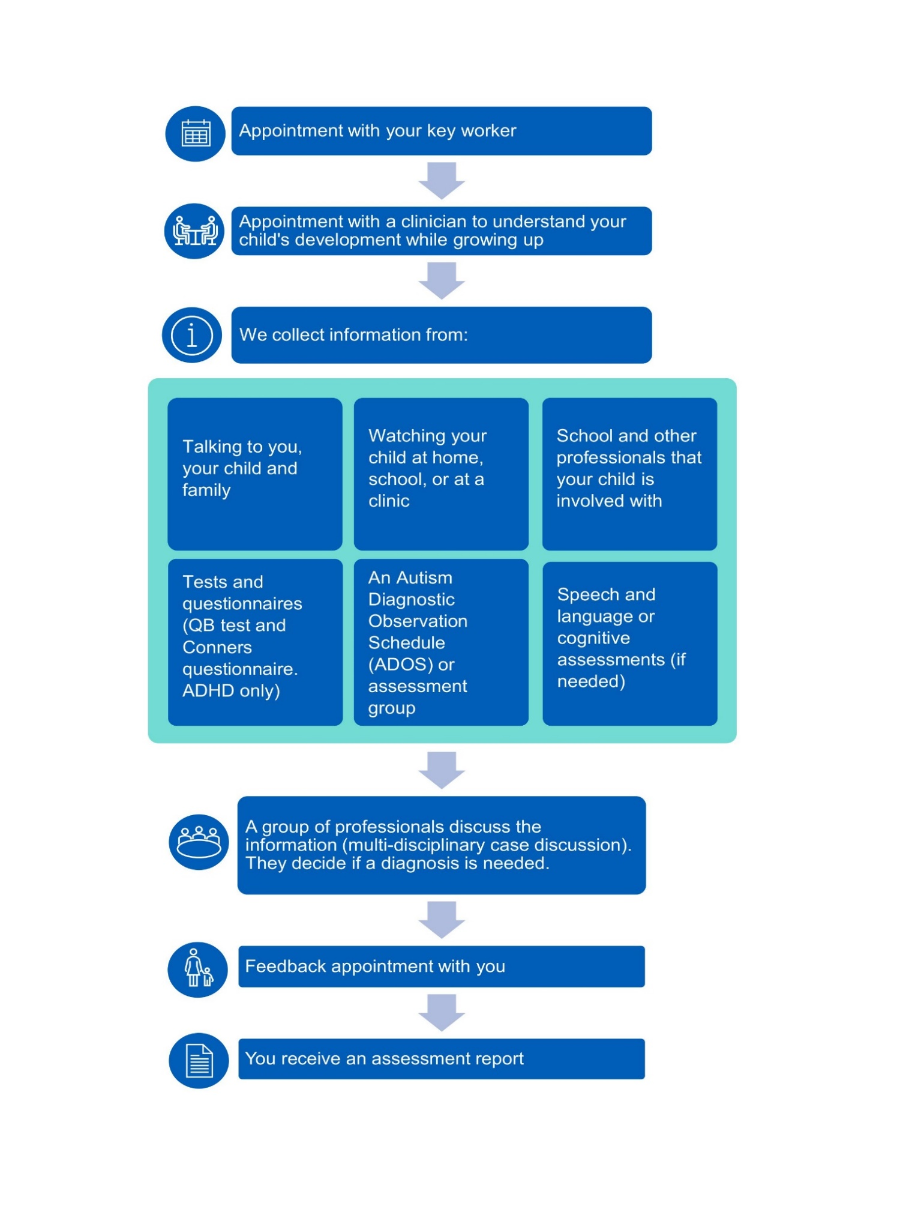

The QB test is a quantitative behaviour test. The Conners questionnaire is used to assess ADHD symptoms.

Section 2: Advice from parents and carers

We know that the process of getting a diagnosis for your child can be long and overwhelming. It is difficult to know what to expect. Here are some of the things other parents and carers have found helpful.



Keep a diary

Keep a diary of your experiences and concerns about your child. This can help when you are talking to professionals or giving information for a referral.



Don't compare your child to someone else's

Your child's development and progress will be different to another child's.

Neurodevelopmental need is a spectrum. There are some things that we look for when making a diagnosis. But how these things look in your child will be different to how they show up in someone else.



Talk to others and try not to become isolated

It's easy to feel alone when you find out your child has a neurodevelopmental need. This can be especially true if your child's behaviour is challenging. But other parents and carers have been through this too.

In Gateshead, there are groups run by parents of children with a neurodevelopmental disorder. They will be happy to chat with you about their experiences. They can share things that they found helpful.



Take notes

When you go to appointments, you often get lots of information at once. Sometimes this can be too much. If you can, take a pen and paper with you. Write down anything that seems important or helpful. This will help you remember it later.



Ask questions

You will have lots of questions throughout this journey. It is never the wrong time to ask them, or to ask for another explanation if you don't understand the answer.

You will get a co-ordinator. They can answer your questions about the process and what to expect.

If you need more practical help, the services in section 3 can help. Even if the person you speak to doesn’t know the answer, they will know someone who will.



Go on courses

Lots of organisations offer free training for parents and carers. These courses can help you to meet your child's needs. Some are about a particular diagnosis, such as autism or ADHD. Others are about how to deal with things like sleeping or going to the toilet.

Training can't give you all the answers. But it can still give you lots of information and tips on how to support your child.



You do not need a diagnosis to get the support you and your child need

More people than ever have neurodevelopmental needs. This means people have to wait longer for a diagnosis. But help is available, and you do not need a diagnosis to use many of these services.

Section 3: Support you can access now

The services below can give you help and advice while you wait for your child to be diagnosed.

Here is a quick guide to what they can offer. There is more information on their websites, or in the A to Z section (page 12 onwards).

Services quick guide

|  |  |  |
| --- | --- | --- |
| **Autism support services** | | |
| **Autism Central** | Information, courses and coaching | <https://daisychainproject.co.uk/autism-central/> |
| **Gateshead Autism Hubs** | Advice and support for parents and carers | <https://daisychainproject.co.uk/gateshead-autism-hubs/> |
| **Toby Henderson Trust** | Support before, during and after the diagnosis process | [www.ttht.co.uk](http://www.ttht.co.uk) |
| **SEND support services (Special Educational Needs and Disabilities)** | | |
| **Citizen's Advice** | General advice and information, including a service for people living with neurodiversity | <https://citizensadvicegateshead.org.uk/services/living-with-neurodiversity/> |
| **Gateshead Council Short Breaks Scheme** | Breaks and activities for children with disabilities and their families | [www.gateshead.gov.uk/article/4010/Short-break-services](https://www.gateshead.gov.uk/article/4010/Short-break-services) |
| **Gateshead Parent Carer Forum** | Group of parents and carers of children and young people with SEND | [www.gatesheadparentcarerforum.co.uk/](http://www.gatesheadparentcarerforum.co.uk/) |
| **Gateshead SEND Local Offer** | Information about the services available for children with SEND and their families | <https://gateshead-localoffer.org/information-advice-services-and-support/> |

|  |  |  |
| --- | --- | --- |
| **Family support services** | | |
| **Gateshead Council Early Help** | Support for families who need help dealing with a problem | [www.gateshead.gov.uk/article/13425/Early-Help-](http://www.gateshead.gov.uk/article/13425/Early-Help-) |
| **Gateshead Family Hubs** | Welcoming spaces for families, with activities and support | [www.gateshead.gov.uk/article/22551/Gateshead-Family-Hubs](http://www.gateshead.gov.uk/article/22551/Gateshead-Family-Hubs) |
| **Healthy Relationships Pathway** | Help with improving family relationships | <https://www.gateshead.gov.uk/article/13571/Support-for-family-relationships> |
| **Support for children and young people** | | |
| **Gateshead's Children and Young People's Primary Care Mental Health Service** | NHS mental health services | [www.stsftmentalhealth.nhs.uk/our-services/gateshead/children-and-young-peoples-primary-care-mental-health-service](http://www.stsftmentalhealth.nhs.uk/our-services/gateshead/children-and-young-peoples-primary-care-mental-health-service) |
| **Gladstone Terrace Centre for Young People** | Youth centre and youth group |  |
| **Young Women’s Outreach Project** | Services and projects for young women | <https://sites.google.com/ywop.co.uk/home> |
| **Activities** | | |
| **Baby Sensory** | Sensory development sessions for babies | [www.babysensory.com/gateshead](http://www.babysensory.com/gateshead) |
| **Twisting Ducks Theatre Company** | Performing arts sessions for adults with learning disabilities | [www.thetwistingducks.co.uk/take-part](http://www.thetwistingducks.co.uk/take-part) |

Services A to Z

Autism Central

Autism Central provides information, courses and coaching for families, parents, carers, and personal assistants. In the North East and Yorkshire, it's run by Daisy Chain.

They offer:

* 1 to 1 appointments
* online support sessions
* online workshops

There is more information on this website: <https://daisychainproject.co.uk/autism-central/>

If you think one of these sessions would help you, please contact [support@daisychainproject.co.uk](mailto:support@daisychainproject.co.uk).

You can also fill in this contact form: <https://daisychainproject.co.uk/ac-contact-form/>

Baby Sensory

Baby Sensory is for babies aged 0 to 13 months. These classes aim to help your child with their learning and sensory development.

You'll get ideas for creative play, massage, tummy time and more. Learn to use songs and rhymes to help your baby develop early speech and language skills. Or try sensory signing activities to help you and your baby communicate from birth.

Find out more here: [www.babysensory.com/gateshead](http://www.babysensory.com/gateshead)

Get in touch by calling 07710 161 671 or emailing [gateshead@babysensory.co.uk](mailto:gateshead@babysensory.co.uk)

Citizen's Advice

Citizens' Advice provide advice and information that you can trust. Their support is free and impartial. Advisers help figure out the best things for you based on what you need.

They have a new service for people living with neurodiversity. Find out more here: <https://citizensadvicegateshead.org.uk/services/living-with-neurodiversity/>

Gateshead Autism Hubs

Gateshead Autism Hubs are for parents and carers of children and young people with autism (0 to 25 years). They offer information, advice, and support.

The Hubs provide:

* drop-in sessions
* peer support groups
* training for parents, carers, and professionals

They can also give advice and point you towards services for other conditions, including:

* FASD (Fetal alcohol spectrum disorder)
* ADHD
* sensory differences
* social and communication differences
* mental health
* learning disabilities

Gateshead Autism Hubs are free for parents and carers. You do not need an autism diagnosis to use any of their services.

Here is some more information about what the Hubs do:

* Autism awareness training for parents and carers

These free sessions aim to help you feel more confident in supporting your child. The sessions will help you to understand your child's needs and behaviour. They will also teach you about strategies you can use.

The sessions are all 9:30am to 12:30pm. They take place at:

Deckham Family Hub

The Elgin Centre

Elgin Rd

Deckham

Gateshead NE9 5PA

Find out about future sessions and book a place here: <https://daisychainproject.co.uk/product/autism-awareness-training-for-parents-carers/>

If you have any questions you would like to ask before you book, please email [gatesheadautismhubs@daisychainproject.co.uk](mailto:gatesheadautismhubs@daisychainproject.co.uk)

* Parent support groups

These groups are a safe space for parents and carers to meet others in a similar situation. Parents and carers can support each other and share their experiences and ideas. A Gateshead Autism Hubs team member is also there to help.

The sessions are relaxed and informal. You can talk about anything you might be struggling with, as well as sharing positive stories and tips. Some sessions take place face to face. Some are online.

For dates of future sessions and how to book, visit:

<https://daisychainproject.co.uk/gateshead-parent-support-groups/>

* Multi-agency sessions (support services drop-in)

There are lots of services and organisations that can support you and your child. At our multi-agency drop-ins, we get them together for you all in one place. You don't need to book or tell us you're coming. Just pop by on one of the dates.

The drop-ins are held at:

* Deckham Family Hub (The Elgin Centre)
* Blaydon Family Hub

You can find dates and times for these sessions here: <https://daisychainproject.co.uk/gateshead-multi-agency-drop-ins/>

If you have any questions you would like to ask before you come to a session, please email [gatesheadautismhubs@daisychainproject.co.uk](mailto:gatesheadautismhubs@daisychainproject.co.uk)

Gateshead Children and Young People's Primary Care Mental Health Service

Gateshead's Children and Young People's Primary Care Mental Health service run drop-in sessions with children’s therapists and wellbeing practitioners. They can offer you advice and information.

Sessions take place on different days and times. They run in local venues, such as the Baltic. You do not need to book. Your child does not need to have used mental health services before.

Find more information on this website: [www.stsftmentalhealth.nhs.uk/our-services/gateshead/children-and-young-peoples-primary-care-mental-health-service](http://www.stsftmentalhealth.nhs.uk/our-services/gateshead/children-and-young-peoples-primary-care-mental-health-service)

You can also email [stsft.gatesheadcyppcn@nhs.net](mailto:stsft.gatesheadcyppcn@nhs.net)

Gateshead Council Early Help

Children and families can need help at any stage in a child's life. When help is needed, it's best to act early, rather than waiting until things get worse.

Early Help is all about supporting you and your child as soon as a problem starts (or before if we can). It applies to any problem that a family cannot deal with on their own. Every family is different, so there are lots of services and organisations that can help.

The Early Help online hub has more information about how you can get help: [www.gateshead.gov.uk/article/13425/Early-Help-](http://www.gateshead.gov.uk/article/13425/Early-Help-)

Gateshead Council Short Breaks Scheme

Short breaks let disabled children and young people spend time with friends, do fun activities, and gain new skills and independence. They also give parents and carers a break from their caring role. This used to be called "respite".

Short breaks come in all shapes and sizes. They can be a break for a child away from their family. Or it can mean helping families to take a short break together. Short breaks can last a few hours, a day, overnight or longer. They can take place in or away from the family home.

Examples of short break services include:

* out-of-school clubs
* youth clubs at evenings and weekends
* 1 to 1 support from short break workers
* family-based breaks provided by carers and specialist childminders
* overnight stays at our residential unit Grove House

The type of short break you may be able to get will depend on your child's needs. You may need a referral.

Find more information here: [www.gateshead.gov.uk/article/4010/Short-break-services](https://www.gateshead.gov.uk/article/4010/Short-break-services)

You can call the Referral and Assessment Team on 0191 433 2653.

Gateshead Parent Carer Forum

Gateshead Parent Carer Forum is a group of parents and carers of children and young people with SEND.

Parents and carers can meet together in a relaxed atmosphere.

They offer:

* drop-in coffee mornings
* information sessions
* training events

There is more information on their website: [www.gatesheadparentcarerforum.co.uk/](http://www.gatesheadparentcarerforum.co.uk/)

Gateshead SEND Local Offer

There is lots of information and support available for children and young people with special educational needs and disabilities (SEND) and their families. The council has put all this into one handy webpage. This is called the SEND Local Offer.

It includes information about:

* services and support
* education
* health and social care
* transport

Find out more on this website: <https://gateshead-localoffer.org/information-advice-services-and-support/>

You can also keep up to date by following the Gateshead Local Offer Facebook page: [Gateshead SEND Local Offer | Facebook](https://www.facebook.com/GatesheadSENDLocalOffer)

You can email the team at [senteam@gateshead.gov.uk](mailto:senteam@gateshead.gov.uk), or phone 0191 433 3626

Gateshead Family Hubs

Gateshead's Family Hubs are welcoming spaces for families. They offer lots of activities and support. If your child has special educational needs and disabilities (SEND), they can offer support until your child is 25 years old.

There are 9 Family Hubs across Gateshead:

* Birtley Harras Bank
* Blaydon Winlaton
* Chopwell
* Chowdene
* Deckham
* Felling
* Leam Lane
* Teams
* Wrekenton

This leaflet tells you more about the support available:



You can also find more information on their website or Facebook page: [www.gateshead.gov.uk/article/22551/Gateshead-Family-Hubs](http://www.gateshead.gov.uk/article/22551/Gateshead-Family-Hubs)

[www.facebook.com/GatesheadFamilyHubs/](http://www.facebook.com/GatesheadFamilyHubs/)

Gladstone Terrace Centre for Young People

This youth centre offers support to young people aged 11 to 25. The service is still being developed, but you can get in touch to see what support is available.

They have an LGBTQ+ social group called PLUS Group. This is an informal group where the young people take the lead. There is also some one-to-one support available through this group.

Please contact [rhoda@gladstoneterracecentre.org](mailto:rhoda@gladstoneterracecentre.org) or [plusgroupnortheast@gmail.com](mailto:plusgroupnortheast@gmail.com) or call 0749 5836 069 for more information.

Healthy Relationships Pathway

The Healthy Relationships Pathway aims to improve family relationships. It does this through group sessions and online learning.

Find out more here: <https://www.gateshead.gov.uk/article/13571/Support-for-family-relationships>

Toby Henderson Trust

The Toby Henderson Trust is a charity that supports people with autism before, during and after the diagnosis process.

They offer:

* private diagnosis and assessment
* webinars
* family support
* working directly with children

For more information, see the PDF below.



You can find more information on their website: [www.ttht.co.uk](http://www.ttht.co.uk)

They also have a Facebook page: [www.facebook.com/TheTobyHendersonTrust](http://www.facebook.com/TheTobyHendersonTrust)

Twisting Ducks Theatre Company

The Twisting Ducks Theatre Company make fun, accessible and informative drama about issues that are important to people with learning difficulties. They also run creative activities for adults with learning disabilities.

They run Performing Arts Academies. Here you can work as part of a team to develop new theatre performances. They also have a Band Academy. Here you can set up and run your own band.

Find more information here: [www.thetwistingducks.co.uk/take-part](http://www.thetwistingducks.co.uk/take-part)

Get in touch by calling 0792 516 7775 or emailing [thetwistingducks@googlemail.com](mailto:thetwistingducks@googlemail.com)

Young Women’s Outreach Project

The Young Women’s Project is for young women and mothers aged 11 to 19 years old. They support all young people who identify as women.

They have a range of services. Some may be useful for neurodivergent young people.

Their work includes:

* 1 to 1 support
* group support
* counselling
* workshops
* advice and information about other services or organisations

Call 0191 477 7759 or email [admin@ywop.co.uk](mailto:admin@ywop.co.uk) to find out more.