Childrens Social Care and Lifelong Learning
Education, Schools and Inclusion, SEND Team
Parachute games for children and young people with SEND.

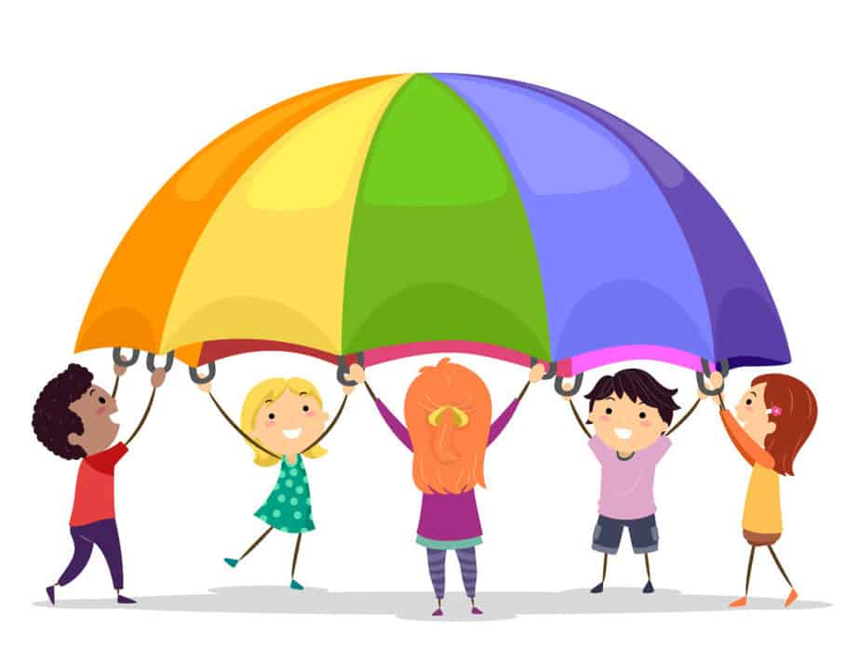

Parachute games are an engaging and enjoyable way to develop communication skills. The games enable participants to co-operate and take-turns with each other leading to an increase in confidence and social interaction. Ideas for games include:

Bouncing balls: Participants move the parachute up and down to make colourful balls bounce up and down on it.

Let’s swap: Two participants are selected then the rest of the group lift the parachute above their heads. The two swap places underneath the parachute before it comes down on them. An extension to this game consists of naming a school, particular clothing etc. and participants swapping places if the object named applies to them.

What’s the time Mr Wolf? A participant pretends to be the wolf whilst the rest of the group asks “What’s the time Mr. Wolf?” If the “wolf” says for example 5 o’clock, the parachute is shaken 5 times. If the “wolf” says “dinner time,” the group have to hide underneath the parachute without getting caught.

Mushroom: Participants lift the parachute high above their heads and then sit on the inside edges of the parachute to create a "mushroom."

Spinning top: A participant sits in the middle of the parachute with their arms up. The others will then walk around holding the parachute and allowing it to partially cover the participant. After three, they will then pull the parachute towards them to enable the participant to spin around.

Moving around: Participants take turns running, walking, rolling on the parachute while others move it up and down.

Traffic light: A participant is selected to use a traffic light tool to instruct when participants should stop, get ready and go i.e. shake the parachute, lift it up or down etc.

Storytelling: Participants make movements of the parachute to represent parts of a story or poem e.g. "sea waves” or “umbrella.”

Action songs: The parachute is used as an aid during action songs. For example, with the song ‘Grand old Duke of York,’ participants can hold the parachute high when “soldiers” are up and low for when the “soldiers” are down.

Orchestra: Participants lift their voices high when the parachute is up and bring it low when the parachute is down

