Happy New Year! Welcome to Gateshead’s first SEND Network Newsletter of 2024.

For more information about the SEND services available to you, go to www.gateshead-localoffer.org, follow the Gateshead SEND Local Offer Facebook page or visit the Gateshead Local Offer YouTube channel.

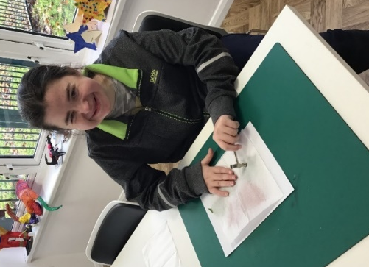  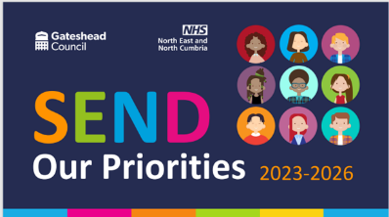  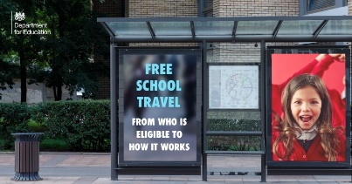  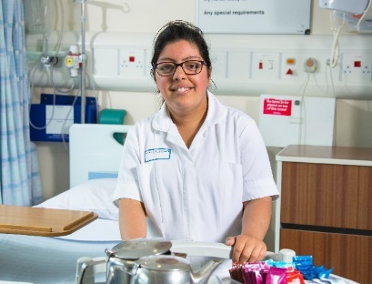 | Gateshead Learning and Skills SEND Provision  Gateshead Learning and Skills have moved their college for young people and adults who have SEND from Low Fell to Birtley. The new site has been designed to be safe and inclusive.  “I think it’s lovely,” says learner Jamie. “You’ve got your friends around you and good teachers. It’s a nice building, there’s more room.” Lauren agrees: “I like it. It’s flat and accessible. It gives us more independence.”  “The transition to our new site has been great,” says Curriculum Lead Chiara Arrighi. “I’m really proud of the learners and the staff - everyone has settled in well. Our provision provides real opportunities for learners to prepare for the next stage of their life, whether that is work, independent living or further learning. We’re all really excited about our future here.”  To learn more about courses, discuss support requirements or to arrange a visit click https://mylearningskills.co.uk/learning-difficulties, phone 0191 433 8646, or email contact@mylearningskills.co.uk  Gateshead SEND Thresholds  The SEND Thresholds were launched at Gateshead Civic Centre on January 11th and 12th with over 400 attendees from Education, Health and Social Care services, as well as the families of children and young people with additional need.  The SEND Thresholds - sometimes called ‘Ranges’ - will provide a framework for all professionals working with children and young people with SEND.  “The SEND Thresholds will provide an invaluable framework for staff in all settings”, says Suzanne Dunn, Service Director for Education, Schools and Inclusion. “Forty settings have been part of a Pilot Trial and have contributed to the final document. Gateshead Council have also recognised the importance of the young person and the family voice and hence we have a section in the Thresholds supporting this. We are delighted to be part of this creative approach and have been supported in all aspects by our professional partners and those within the Parent Carer Forum and SEND Youth forum.”  More details and an electronic version of the Thresholds can be found on the Gateshead SEND Local Offer website: https://gateshead-localoffer.org/send-thresholds/  DfE Free School Travel Blog  When choosing which schools to apply for, it is important to consider how your child will get there. Some children are eligible for free travel, but this isn’t the case for everyone.  To help support with this, the Department for Education have published a blog post on free school travel. The post aims to support parents’ understanding of the eligibility criteria and to answer some commonly occurring questions.  The post is part of the wider DfE Education Hub, which is a site for parents, pupils, education professionals and the media that captures all you need to know about the education system.  Visit https://educationhub.blog.gov.uk/2023/11/03/free-school-transport-explained-eligible-free-travel/ to read the information about free school travel. For the DfE Education Hub, visit https://educationhub.blog.gov.uk/  Gateshead Council SEND Team Update  We have had some staffing changes within the SEND Team. Danny Meek left us in November and we have appointed Jasmine Jones as the new SEND Team Manager. We have also appointed Sam Leaver who was seconded to us from February 2023 on a permanent basis as our Inclusion Quality Assurance & Monitoring Lead. The Council have also provided some additional funding to enable us to appoint an additional Quality Assurance and Monitoring Officer (Helen Dawson) who will take up post after the Easter Holidays together with two additional SEND Caseworkers, Natasha Campbell and Jen Derrett-Purvis who are now permanently with us. Sara Baxter is currently on maternity leave and spending some quality time with her new daughter, Alice.  We now have a vacancy for an Annual Review Officer which is currently being advertised and are hoping to expand the Team further to support our involvement in the Change Programme over the next few months.  NHS Choices College  NHS England Choices College is a national specialist college for young adults aged 16-24 with learning disabilities/difficulties and/or Autism. The organisation – previously known as Health Education England Project Choice - are opening a new provision based at Gateshead’s Queen Elizabeth Hospital in September 2024 and are looking for young people who may be interested in joining the programme.  For more information visit https://www.hee.nhs.uk/our-work/choices-college-supported-internships or contact Stephanie Walker: Stephanie.walker40@nhs.net  Activities, Information and Resources  Are you a parent or carer of a child or young person who has special educational needs and /or disabilities? The NHS North East and North Cumbria Integrated Care Board have created a document to help you find out more about where you can access support or advice to ensure your child’s needs are being met Gateshead: https://gateshead-localoffer.org/send-support-for-young-people-in-gateshead/  Do you want to have a say in how we support children and young people with additional needs in Gateshead? If you are 12-25 years old and have an interest in improving the lives of local young people with additional needs, you can get involved with the Gateshead SEND Youth Forum. If you’d like more information about joining the forum, contact AlexThompson@Gateshead.Gov.UK or visit https://gateshead-localoffer.org/gateshead-send-young-peoples-forum/  Gateshead's Family Hubs provide a welcoming space for families and the wider community. Family Hubs support families from conception to the age of two and continue to support families of children up the age of 19, and to age 25 for young people who have special educational needs and disabilities. There are currently eight Family Hubs located across Gateshead. For more information visit https://www.gateshead.gov.uk/article/22551/Gateshead-Family-Hubs  Contact us!  Special Educational Needs and Disability Team  Gateshead Council  senteam@gateshead.gov.uk  0191 4333626  Follow us on Facebook

