Hello! Welcome to Gateshead’s SEND Network Newsletter.

For more information about the SEND services available to you, go to www.gateshead-localoffer.org, follow the Gateshead SEND Local Offer Facebook page or visit the Gateshead Local Offer YouTube channel.

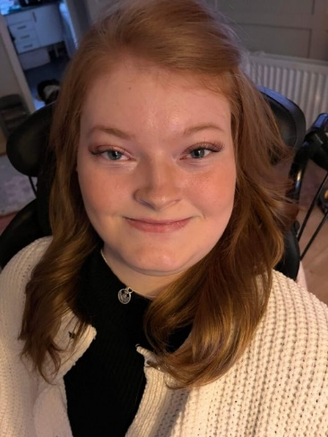  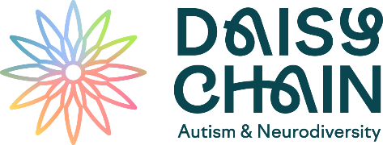 | Demi’s Story  My name is Demi and I’m 22 years old. I’m originally from Fife, Scotland, but I grew up in the North East of England since I was 4. I have so many exciting hobbies. They keep me busy and play a vital role in my creativity. I love reading fictional books. I hope, at some point in my future, that I become an author.  I was diagnosed with Riboflavin Transporter Deficiency (RTD) when I was 10 years old. Truthfully, life with a disability like mine, is depressing. You have an unfair amount of limited activities and then there’s you comparing yourself to able-bodied people. You have to take risks and find other ways to deal with it. There are many other things that I wish I can do and have, things that able-bodied people can have, but they just seem impossible.  I am currently a student attending Newcastle College, doing an Art & Design Level 2 course. I have always loved art. As I grew older, I found a new way to draw as my arms and hands became weaker. I had two options available - I used my mouth and feet!  My favourite part about being creative is living in my imagination. It amazes me to see what I can do in my mind, so I try my best to show everyone what I see, through my writing and my visual art. It also gives me unlimited freedom; to do the things that I can’t do in reality, to have the things that I can’t have in reality and to see the things that I can’t see in reality.  Your body may be disabled, but your mind isn’t! No one is allowed to tell you what you can and can’t do; if you want to be a lawyer, a teacher, an accountant, a gamer, an artist and so on. DO IT! My mouth is my tool, my superpower is my imagination. It may be difficult and challenging to overcome these issues, but isn’t it time to make everywhere wheelchair accessible in today’s world of technology and intellect? We just want the same life experiences as everyone else. There’s only one life to live, let us have a chance to access anything we wish. Don’t overlook our abilities.  To read more about Demi’s Story visit Demi's Story - Gateshead Local Offer SEND 0 to 25 years (gateshead-localoffer.org) and visit https://gateshead-localoffer.org/demi-anderson/ to see examples of her amazing artwork. For more information about RTD visit About RTD - Cure RTD  Gateshead Autism Hubs  North East based charity Daisy Chain has been commissioned to improve and extend the offer of support for autistic people, their families and practitioners across Gateshead.  Gateshead Autism Hubs will offer parents and carers of autistic children and young people information, advice and support on a range of issues. The Hubs provide drop-in sessions, peer support groups, and training for parents, carers, and professionals.  Lynn Wilson, Director of Place Gateshead, North East and North Cumbria ICB and Gateshead Council, said: "It can be difficult to find suitable support when you're the parent or carer of an autistic person, or an autistic person yourself. Autism Hubs bring together helpful, local information and a range of support for autistic people and associated neurodiversities.”  For more information visit Gateshead Autism Hubs - Daisy Chain . For information about Gateshead Family Hubs visit Gateshead Family Hubs - Gateshead Council  Learning Disability Annual Health Checks  Annual health checks are for adults and young people aged 14 or over with a learning disability. Anyone aged 14 or over who's on their GP's learning disability register can have a free annual health check once a year. Adults and young people aged 14 or over with a learning disability who are on the GP practice learning disability register should be invited by their GP practice to come for an annual health check.  Most GP surgeries offer annual health checks to people with a learning disability, but if your GP surgery hasn't offered you a check you can contact them to ask them if they could provide one.  Find out more by watching Introduction to Annual Health Checks for people with a Learning Disability or going to the NHS website Learning disabilities - Annual health checks  Gateshead SEND Thresholds  Gateshead’s Local Authority is developing a new SEND Thresholds model. The SEND Thresholds - sometimes called ‘Ranges’ - will provide a framework for all professionals working with children and young people with SEND. They will provide help in identifying the level of need and will support children and young people with additional needs across schools, colleges and other settings.  “We have undertaken an extensive series of training opportunities across education, health, social care, and families to help make the SEND Thresholds ‘Gateshead specific’”, says SEND educational specialist Anne Hayward. “The Thresholds are based on the four areas of the SEND Code of Practice - cognition and learning, communication and interaction, social emotional and mental health, and sensory/physical. They will give practical guidance and ideas from Early Years to Post 19. It also includes the Preparation for Adulthood (PfA) outcomes from Early Years through to the age of 25.”  All settings will be using the SEND Thresholds from January 2024 and an in-depth moderation event is planned for Summer 2024.  Activities, Information and Resources  The ‘Supporting Parents New to Hearing Loss’ online events are an ideal opportunity for families to get the  information they need after diagnosis. The full range of events for families and deaf children/young people can be found here Online events and courses for parents and families of deaf children | National Deaf Children's Society (ndcs.org.uk)  The Charlie Waller organisation is a mental health charity which aims to help young people understand their own mental health, to equip them to support themselves and those around them, and  to empower them to talk more openly about the subject. Visit www.charliewaller.org for more details.  Gateshead Council have appointed a new Designated Social Care Officer (DSCO) - Tara O’Donnell - to support with their strategic priorities in relation to children and young people with SEND. This post is positioned in Children’s Social Care and is jointly managed across Children’s Social Care and Education. For more information, visit https://gateshead-localoffer.org/designated-social-care-officer-dsco/  Contact us!  Special Educational Needs and Disability Team  Gateshead Council  senteam@gateshead.gov.uk  0191 4333626  Follow us on Facebook

