Parent Resources FAQs
What will I need to do the course?
- A computer, tablet, or smartphone on which you can play video and sound.
- A good internet connection.
- Any modern web browser (like Chrome, Mozilla Firefox, Safari, or Microsoft Edge). These courses will NOT work with Internet Explorer.
If needed you can download the latest version of Chrome here
If you need to change your default browser to something other than IE please follow the instructions here
I am unable to find my council’s unique link
Go to https://www.oneplusone.org.uk/parent-guide-for-england. Please select the region you are from on the map. Listed under each map will be a list of towns & cities to choose from. The practitioner from your local council who sent you the link should be able to confirm this if you are unsure which one to choose.
Where do I register?
You can do this via your region link above.
I have already registered where do I log in?
Go to https://skills.oneplusone.org.uk/users/sign_in
I have forgotten my password
Go to https://skills.oneplusone.org.uk/users/sign_in and click the ‘Forgot Password’ link. This will ask you for the email address you registered with and once entered will send you a link to reset your password to this same email address.
I see the following error “Internet Explorer does not support the Thinkific platform”
This means you are opening the course within Internet Explorer. Please open the link in a different browser as mentioned above.
I am logged in, but I do not see any courses (as below)
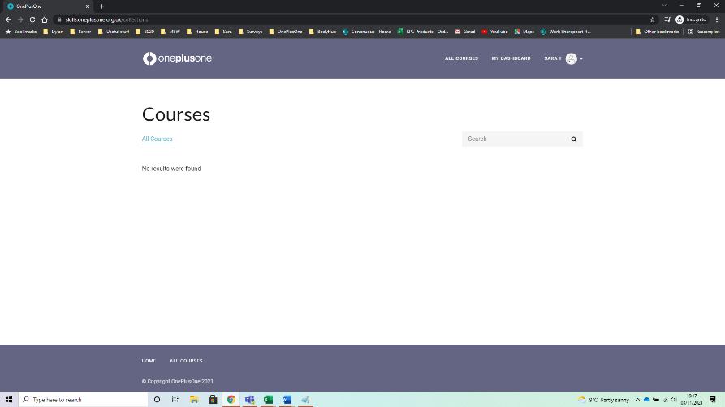
Click on “My Dashboard” at the top right. If you still do not see anything please email info@oneplusone.org.uk with your email address along with your local council's name and this issue will be resolved as soon as possible.
I am logged in but I see the course scrunched up to the left-hand side (as below)
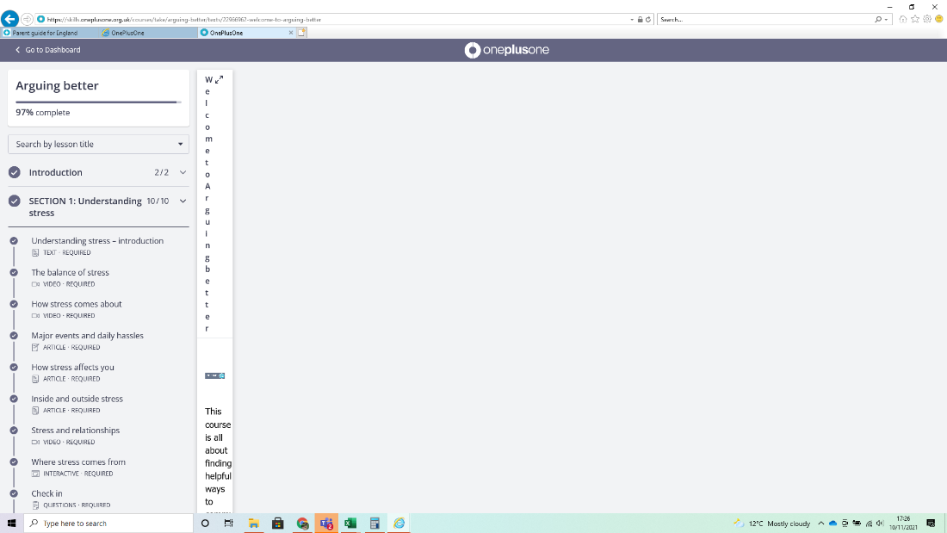
This means you are opening the course within Internet Explorer. Please open the link in a different browser as mentioned above.
Videos are not playing
https://www.nucleustechnologies.com/blog/fix-embedded-videos-not-playing-in-google-chrome/
I see a box saying, “Requirements have not yet been completed!”
Please answer the ‘getting to know you’ questions. These should only take 3 minutes to complete.
Will I get a certificate at the end of the course?
Yes, you will get a certificate for each course completed. The name on the certificate will be the name you registered with at the start.
What information is stored about me?
Please see our Privacy Policy here

