Members who attended:
Danny
Abby
Nicolas
Sophie
Etta

Staff who attended:
Alex
Valerie
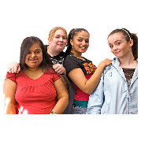  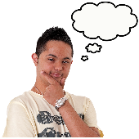 | This meeting took place virtually  Agenda – at this meeting we talked about  - Our lives during lockdown and how we are feeling right now  - Our experiences of inclusion in Gateshead  - Our favourite Easter chocolate  - Any other business?
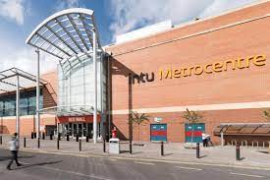  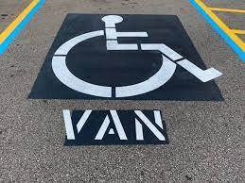 | How do we feel about lockdown and the pandemic?  ‘I’m glad lockdown is ending soon.’’  ‘I’m glad to be back at school / college  Being back at school has been good for my confidence, I had been off for a long time’  ‘I have to wear a mask all day at school, but I’m glad to be back.’  ‘I wish Primark was back open!’  Four members of the group have had their first COVID vaccine. They are feeling positive about this.  What are our experiences of inclusion in Gateshead?  ‘Is funding an issue for inclusivity? There are lots of events in Gateshead but sometimes I feel like I don’t want to go to them in case they are too busy, or I can’t get parked.’  ‘I parked at Saltwell Park and there weren’t enough dropped curbs for my wheelchair. I’m glad that there are van bays for my powerchair though.’  ‘Van bays have been used as Portaloo spaces at Enchanted Parks.’  ‘At the Metrocentre there are loads of disabled bays outside shops, but no van bays.’  ‘I can’t go to the Metrocentre because there are always too many people when I go.’
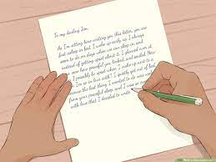 | What can we do about any issues?  Write to Metrocentre to make them aware of lack of disabled van spaces, and to ask about a possible ‘Inclusive Hour’ to help people with sensory issues.  Can we work with council events organisers during planning stage to help them fix any accessibility issues?  What’s the best Easter chocolate?  ‘All sorts of chocolate’  ‘Anything chocolate related!’  Galaxy Cookie Crumble was the most popular.  Everyone did well on the chocolate quiz!
Any other business?

It was asked if there was a plan after lockdown to meet at the Civic Centre.

Staff explained that we can only met virtually until restrictions were lifted. The group agreed that virtual meetings were good for accessibility issues.

The group discussed their ideas for an AGM-style event once a year at the Civic Centre.

‘We could build up over a year about what we want to present to the council – a bit like an AGM. We could present our findings to councillors.’

