[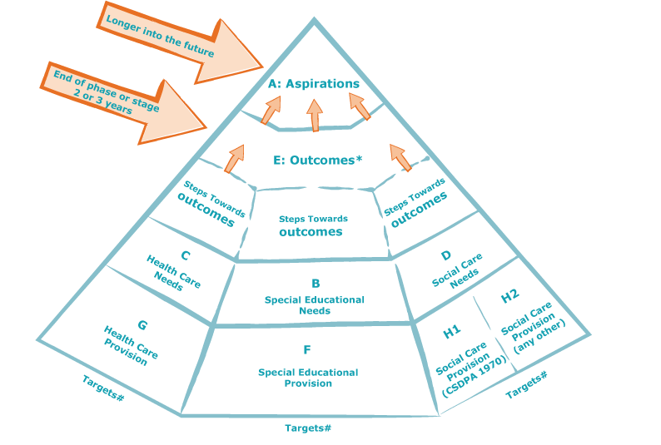](http://training.councilfordisabledchildren.org.uk/course/view.php?id=7)

